3.3 Partial Derivatives

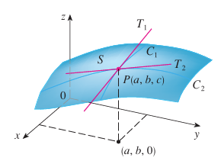
Motivation: Suppose we have a surface given by the two-variable function and a point P (with coordinates of ) on the surface determined by f.

Suppose we want to know the rate at which the z-coordinate changes at P when we are moving across the surface parallel to the x-axis. This means that we would be moving along the curve toward P in the picture above. At this point P we can imagine a tangent line being constructed.

The slope of would then represent the rate at which the z-coordinate is changing at P when moving parallel to the x-axis.

Suppose we want to know the rate at which the z-coordinate changes at P when we are moving across the surface parallel to the y-axis. This means that we would be moving along the curve toward P in the picture above. At this point P we can imagine a tangent line being constructed.

The slope of would then represent the rate at which the z-coordinate is changing at P when moving parallel to the y-axis.

In Calculus I we found slopes of tangent lines to a curve by calculating the derivative and evaluating it at the appropriate point.
In Calculus III for a function we also need a way to find a derivative, but in a way that allows us to account for the direction that we are moving along the surface. This leads to the idea of what we call partial derivatives.

Note: The information that we are seeking above can be key when one wishes to better understand how quickly a surface is changing at a point.

Definition: If is a function of two variables, its partial derivatives are the functions and defined by: and .

Note: represents the rate of change of z with respect to x when y is fixed, and is the rate of change of z with respect to y when x is fixed.

Note: In the context of the motivation, we would use to find the slope of the line tangent to the brown curve at P, and we would use to find the slope of the line tangent to the green curve at P.
Notation: There are many notations for partial derivatives. We go over 7 possibilities. If , we write

Example 1: If , find and .

According to the definition, to find , we think of y as a constant and differentiate with respect to x.
So, .

According to the definition, to find , we think of x as a constant and differentiate with respect to y.
So, .

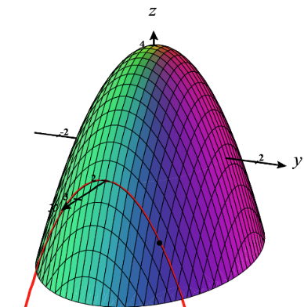
Example 2: Consider the surface given by . Let C be the curve of intersection between this surface and the plane . Find the slope of the line tangent to C at the point on the surface.

We know that the answer to this question will be . So, we note that .
Then the answer is: .

Note: The instructor will illustrate the idea behind this example with a three-dimensional plotter.

Example 3: Find if z is defined implicitly as a function of x and y by .

We differentiate both sides of the equation with respect to x while being careful to treat y as a constant and use the chain rule, we obtain:

Note: There is a fairly subtle point that could be made about the above example. In particular, we assumed the equation defines z implicitly as a function of x and y. What guarantees that the above equation defines z implicitly as a function of x and y? In order to fully answer this question one needs the implicit function theorem (the proof of which is beyond the scope of this course).
We can easily extend the notion of partial derivatives to functions of more than two variables (though in these cases a geometric interpretation becomes more difficult). For example, Suppose that is a function of three variables x, y, and z. Then, its partial derivative with respect to z is defined as . So, in order to compute we think of x and y as constants and differentiate with respect to z.

Ex: If , then .

Definition: If is a function of two variables, then and are functions of two variables. The functions , , , and are called the second partial derivatives of f. If , we use the following notation:

Example 4: Find all four second partial derivatives of .
We first note that and .
This means that ,
, , and
.

Note: Interestingly, in the above example and are the same! The next theorem addresses this.

Note: As one would probably expect, the second partials and tell us something about the concavity of the curve of intersection between the surface given by and a plane of the form or . We will see some more applications of these second partials later in chapter 4.

Note: It is more difficult to perceive what the second partials and tell us. What does communicate is how the slope of the tangent line with respect to x changes as the value of y varies (similarly for ). To see an animation of what we mean by this one can visit the following website:
https://web.archive.org/web/20180215172659/http://www.math.harvard.edu/archive/21a_fall_08/exhibits/fxy/index.html
Theorem: Suppose is defined on a disk D that contains the point . If the functions and are both continuous on D, then .

Proof: Beyond the scope of this course

Note: In the most recent example, and are continuous on all of , and we saw that they were indeed equal.

We can have partial derivatives of order 3 and higher.

Example 5: If , then find .

We note that . Then, .
Finally, we have that .

